## Section V: Interactive Maps

**Preparation:** The interactive map feature is a Public Access tool which allows customers to quickly reserve Facilities by viewing available options on a map instead of using a list. This feature is only available on Public Access site.

For this module you’ll need facility layout map(s) (JPEG format), and a set of suitable icons (JPEG or ICO format). For training purposes you may use the graphics below. You’ll need to copy-past these into an imaging processing software – MS Paint should suffice. NOTE: Ensure the image is properly cropped before saving the image as a JPEG in MS Paint.

### Lesson 1: Enable Map Settings Feature

Details: In this lesson you’ll be using Center # 3 created in one of the earlier lessons. The Center has meeting rooms, a gymnasium, and a Swimming Pool. Specifically you’ll be implementing an interactive map for the swimming pool which allows the public user to visual reserve a swimming lane.

* Before creating the Interactive Map, ensure the centers with facilities that will be utilizing this feature are enabled.
* Select Center # 3 (or whatever you named the center) and click ‘Change Center Details’ under functions.
* At the bottom of the form, check-mark the ‘Configure Map’ Setting.
* *Tip: Locations > Centers > Change Center Details*

### Lesson 2: Configure Map Images and Icon Set

**Details:** Obtain relevant button icons from the internet (or create your own). You may use the swimming pool map listed below. (Copy the image, and paste it in MS paint. Save as JPEG after cropping the image)

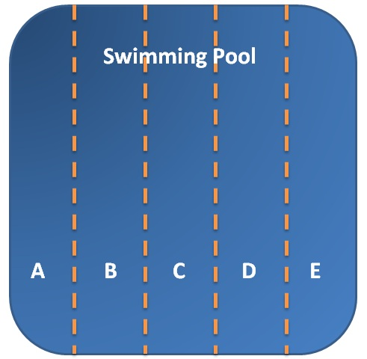

* Upload the map to the database. Make sure to enter a name and Description for the map
* Upload three icon images (for ‘Open’, ‘Booked’ and ‘Closed’ statuses) to the database. Make sure to select the option ‘Use as Map Icons’ for these three uploads.
* Create Icon sets via clicking ‘Add New’ under ‘Icon Set’ Section. Name the set and use the binocular button to pull icons added in the previous step.
* *Tip: System Settings > File Upload*

### Lesson 3: Configure Facilities to connect to the icon images

**Details**: Bind icons to Facility and create default reservation settings for the interactive map.

* In facility Types, select swimming lane, and scroll to the bottom of the detail page to enable ‘Display on Map’ feature.
* Once enabled, populate the now visible ‘Set Icons’ with the icons set we created in the previous lesson.
* Also fill in the ‘Default Reservation Details’ for Interactive Maps. This includes Event Type, Event Description (can be modified by the customer when reserving facility), and the number of guests.
* *Tip: Facility Settings > Facility Types*

### Lesson 4: Configure Center to connect to the map.

**Details:** Add map(s) to a center and connect everything together.

* Go back to ‘Centers’ under Locations drop-down, and Select Center # 3 (or whatever you’ve named your center).
* Under functions, click on ‘Change Center Map Configuration’ and add a new map. Give the map a name; call it ‘Pool Map’, select the map image you uploaded in one of the earlier steps, and a description and click save.
* Click on Pool Name in the interactive map list. Position icons for each of the lanes via drag-and-drop. The icons will represent the individual facilities associated with the center. Note that this configuration will automatically save on its own.
* *Tip: Locations > Centers > Center # 3 > ‘Change Center Map Configuration’*

### Lesson 5: Test/Reserve using Interactive Maps in Public Access

* Navigate to the Public Access URL, and log in to a Customer Account
* Navigate to Reservations and select the ‘View Locations Maps’ button
* Select the preferred date and time range for booking Facility. Note: You may not be able to reserve the facility if you’ve set a time window before accepting reservations.
* Select the facility (i.e. a swimming lane) and slick on the reserve button